Broadcast Electronics
bdcast.com
1

Tomorrow’s Radio Today

BE-TEST RECEIVER
FM DIRECT SAMPLING TEST SYSTEM
AVATAR

Such functionality is irreplaceable when you need to analyze and confirm the operation of your broadcast equipment and antenna. All displays can be easily saved and exported so that they can be compared later. The saved displays can then be available for future analysis or could be kept on record.

No external power supply needed. It is exceptionally small, compact and weighs less than a pound (<0.5kg). Fits in your briefcase and can go anywhere.

A simple USB 2.0 port connection to an ordinary Windows PC and the FMDSTS-AVATAR becomes an excellent tool for analyzing and setup of the whole broadcast equipment on-site. It can measure the RF spectrum in both standard and spectrogram views with a display of the complete Multiplex Spectrum up to 95 kHz and the audio spectrum up to 16 kHz. It provides a bar graph display and text for all RDS/RBDS and Stereo Pilot levels and details combined with graphical displays of Deviation, Deviation History and a Deviation Histogram. Additional information in graphical form for Stereo Quality, a full Stereo Monitor and a constant measurement of Modulation Power and most importantly the on-air signal to noise ratio (SNR). This patent pending technique is perfect for a quick understanding that your stations is sounding great.

Easy switching between RDS/RBDS standards and pre-emphasis measurement units makes FMDSTS-AVATAR a suitable choice for broadcast engineers from all around the world.

The FMDSTS-AVATAR gives you real-time live visualization of your station and then a quick comparison to up to nine other stations.
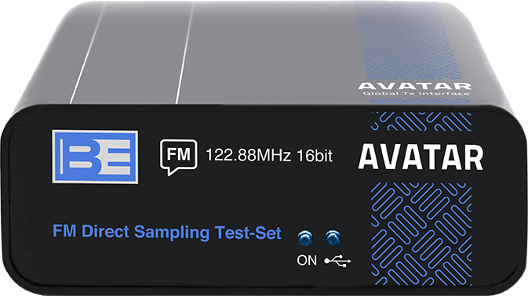

Made in Europe, designed in Italy, supported from the USA
The FM Direct Sampling Test-Set from Broadcast Electronics is the latest in a range of new FM products released by the Elenos Group. Due to the 16-bit direct RF processing and an extremely high-quality front-end receiver the accuracy is far beyond that of comparative products. The FMDSTS-AVATAR provides a unique continuous measurement of the audio Signal-to-Noise ratio without interrupting the on-air audio program content.

It is the ideal tool for engineers, perfect for master control monitoring and provides an excellent visual display for studio lobbies or anywhere you want people to “see” your radio station.

The FMDSTS-AVATAR test receiver is a multifunctional, easy to use tool, designed to evaluate FM broadcast quality, with the ability to save important radio broadcast parameters in the file of your choice. This is a stand-alone solution for monitoring and no additional tools are needed, just a standard Windows 10 PC for display. You can setup for observation up to 10 preselected channels. The display allows you to know how your station compares to others, it can be used at the station for visual off-air confirmation, 24 hour monitoring of key specifications or using in the field for coverage analysis, by comparing all your competitors in just a few simple clicks.

BE-TEST RECEIVER
FM DIRECT SAMPLING TEST SYSTEM
AVATAR

BE FM Direct Sampling Test Set
Hardware and OS minimum requirements
• Windows 10
• RAM: 4 GB
• CPU 2.5 GHz - 4 Core
• HD: 10 GB free
• Screen 1600x900

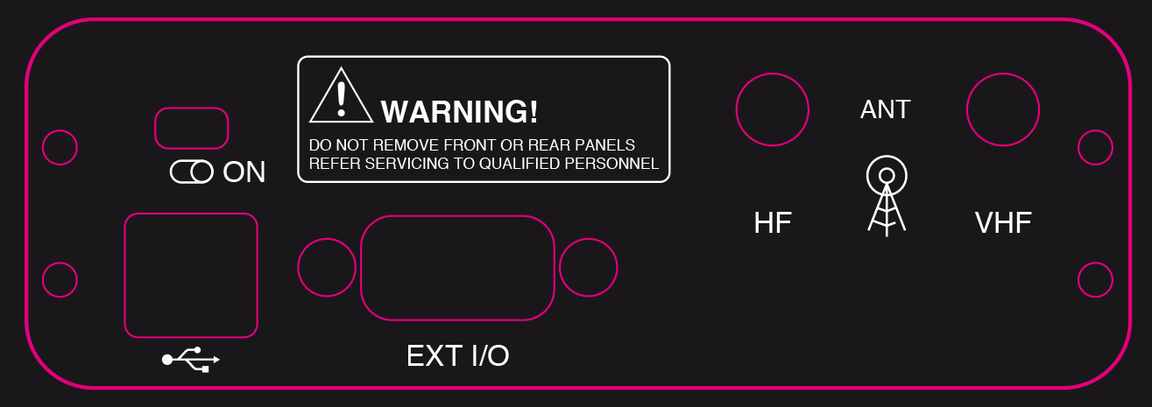
Made in Europe, designed in Italy, supported from the USA
Key Features & Benefits

- Compact and lightweight
- AM and FM inputs
- No Power Supply required
- Complete remote monitoring of any site anywhere in the world
- Ten easy set presets
- Ten Graphical displays
- Complete RDS/RBDS monitoring
- 24/7 Signal to Noise (SNR) measurement without removal of audio program/content
- RF spectrum allows viewing of the main and two adjacent channels at one time
- Displays HD Radio® sidebands in RF *
- Displays Multiplex spectrum, ideal for quick visual sub-carrier confirmation
- Stereo quality display, ideal for confirming left and right separation
- Easy measurement of Stereo Crosstalk up to 110dB sensitivity
- Mono/Stereo light
* Note: this is not an HD Radio receiver and cannot demodulate HD Radio program content.
Broadcast Electronics
2 bdcast.com

BE-Test Receiver
FM DIRECT SAMPLING TEST - AVATAR

Frequency Range
FM: 87.5 - 108 MHz, All the STL IF Monitor frequencies:
10.7 – 21.4 – 70 – 140 MHz and HF: 0.1 - 30 MHz (only WFM demodulation on all bands)
VHF
SMA female, 50 Ohms with BNC adaptor
Windows® PC
Windows 10 (Windows 7 also typically works but depending on the hardware not guaranteed)
RAM: 4 GB
CPU 2.5 GHz - 4 Core
HD: 10 GB free
Screen 1600x900

bdcast.com 3

USER INTERFACE/ REMOTE CONTROL
PC USB USB 2.0 Standard B (1 = +, 2 = D-, 3 = D+, 4 = -)
HF
SMA female, 50 Ohms with BNC adaptor
RF INPUTS

GENERAL

SPECIFICATIONS

DISPLAYS

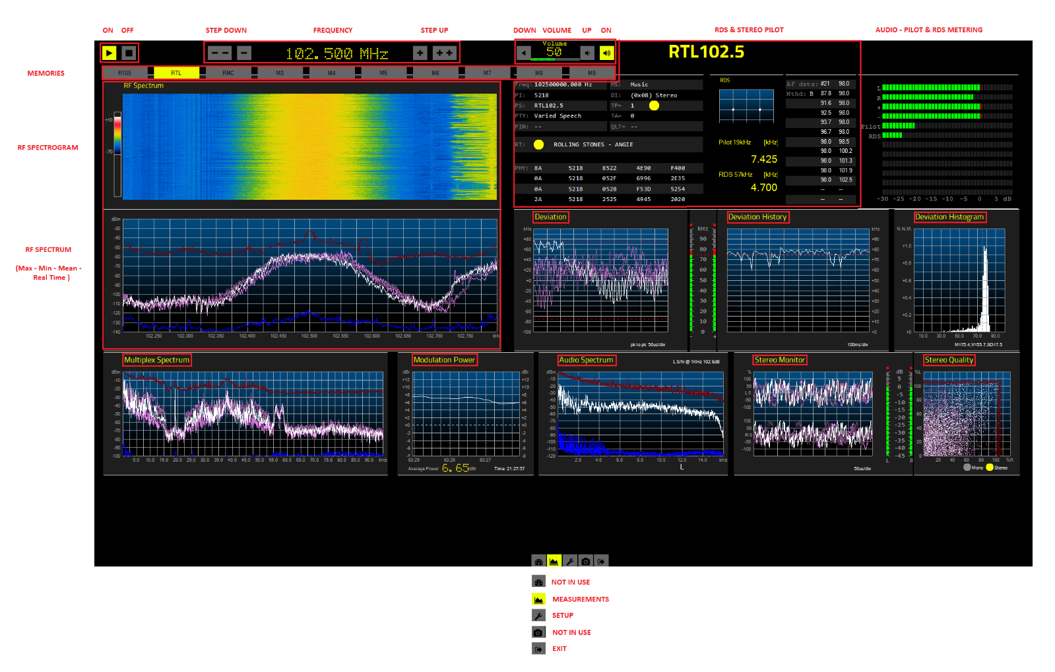


BE-Test Receiver
FM DIRECT SAMPLING TEST - AVATAR

AC Input
Frequency
50 or 60 Hz
4 bdcast.com

Power Factor

Taking the next step is easy with Broadcast Electronics. Contact your sales representative today to discuss solutions that will work for you and your station(s).
To contact your BE sales representative, simply visit our website at bdcast.com or call 217.224.9600 and learn more about what BE has to offer.
BE manufactures complete RF systems for radio and TV.
Our products encompass program generation, audio and data management, interfacility transport and analog and digital Radio and TV transmission.
BE and Elenos Group products are used daily in more than 40,000 installations in nearly 100 countries. For over sixty years, BE pioneering developments have set industry standards for innovation and reliability, while providing broadcasters with new options for operational productivity and income generation.

BE is headquartered in Quincy, Illinois, USA, and is represented worldwide by a network of local representatives.
Telephone (217) 224-9600
4100 North 24th Street ― Quincy, Illinois 62305-3606 U.S.A
©2020 Broadcast Electronics. All rights reserved. Specifications are subject to change without notice. Broadcast Electronics and the BE logo are registered trademarks of BEI Electronics LLC. All other trademarks are property of their respective owners.
www.bdcast.com
Tomorrow’s Radio Today
BE - Broadcast Electronics is part of Elenos Group more information www.elenosgroup.com Headquarters in Italy
Broadcast Electronics
4 bdcast.com
BE FM Test Set – Avatar March 17, 2020 2:15PM

